Stat 401: Introduction to JMP

**Overview:**

JMP is a point-and-click menu-driven program. That means you don’t have to write code to conduct an analysis. There is the option to save an analysis as a JMP script. However, it is hard to read and revise JMP scripts.

Two practical consequences of the menu interface are:

1) it is easier to locate the analysis you want (good).

2) it will be laborious when you want to run similar analyses on lots of data sets or on lots of variables in one data set (bad).

**Installation:**

I recommend you use JMP 13 Pro. That is available in all Stat department computing rooms (1104 Snedecor, 3121 Snedecor, 2272 Gilman). JMP is also available in most ISU computing labs.

If you want to install JMP on an ISU or personal computer, it is site-licensed software. Go to <https://stat.iastate.edu/statistical-software-jmp> and follow the link to installer. You will need an ISU netid. JMP comes with an annual license. The current license expires 1 July 2018. To continue using JMP after that, you will need a netid to get the new license information (from the stat JMP site).

The JMP download is large, ca 850 Mb. Best from on campus or using a fast broadband connection.

**Overview:**

When you start JMP 13, you get a tips window, which you eventually want to close, and the Home Window. Initially, that contains two panels: Recent Files and a Window List. The Window List simplifies navigating the various windows that will pop up as you do an analysis. Recent Files simplifies restarting an analysis.

JMP, like R and SAS, requires that a data file be read into the program before you can do statistical analysis with it.

**Reading a data file:**

Click File / Open from the main (top) menu bar. By default, JMP gives you a list of all possible file types .csv is comma delimited, .xlsx is an Excel workbook, .txt is space delimited, and .jmp is a JMP workbook. Click the name of the desired file, then click open. You get a new window with JMP’s view of the data in that file.

Most of the time JMP reads a file correctly. Sometimes it gets confused. If the JMP version is not what you expected, you need to help JMP read the file. After you click the name of the desired file (but before you click open), you will see a set of buttons labelled Open as below the file list. The default setting is using Text Import preferences. If that doesn’t work correctly, click with Preview, then click Open. You get a window box that allows you to modify how the file is read. The preview window shows how JMP will read the file. The vertical line in that preview window shows where one variable ends and the next starts. The next Import preview window allows you to change variable(column) names and other characteristics of the column. Import then reads the file.

Download and read the creativity.csv file into JMP.

After you read the file, you will see there is a data window called creativity in the window list.

**Histograms:**

There are various ways to create plots in JMP. You are welcome to use what works for you. I will demonstrate Graph Builder.

To get a histogram of all the observations:

click on the data window to make it active

Graph / Graph Builder from the main menu

Find the name of the variable to plot in the variables box (left of Graph Builder window)

we want to plot score

drag that variable to the x box (bottom of the middle of the Graph Builder window)

The graph type (shown by the icons at the top middle) will be dots.

You will get a horizontal dot plot of data.

Click the histogram box (10’th from left, highlight below) to get the histogram

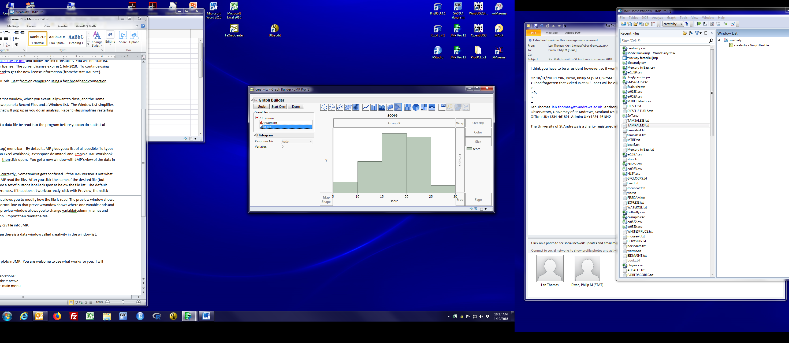

To get a sense of the logic of Graph Builder: click Start Over

drag score to the y box (left hand side of the middle)

then click histogram

you get a sideways histogram

The icon 7 from the left is a bar chart, which shows the mean, not a histogram

To get stacked histograms for each group, remake the vertical histogram, then

drag treatment to the Group Y box (right hand side of the middle).

And if you want side-by-side histograms, undo the stack, and drag treatment to the Group X box

When you like the plot, click Done (top left of the Builder window)

The result is a window with the plot

**Including a Graph Builder plot in a Word (or other) document:**

I know three ways to do this:

1) There is a menu bar hidden at the top of the graph window. You need to click the thin **light blue** bar at the top of the window to see it. Then click File / Save as, change the type to your favorite graph format, then save the figure. You can then Include / Picture into a Word document.

2) Instead of File / Save as, use Edit / Copy to copy the file to the clipboard, then paste it into your Word document. If the Graph window is the active window, the usual keyboard shortcut for copy, Ctrl-C, will copy the graph to the clipboard.

3) We’ll talk later about using the Windows Journal. If you store your results in a Journal, you can easily cut and paste figures or numbers from the Journal them into a Word or other document.

**Box Plots:**

Start Graph Builder. Since box plots are usually vertical (so values go up-down):

drag score to the y box.

click the box plot icon.

and you get a box plot of all 47 observations

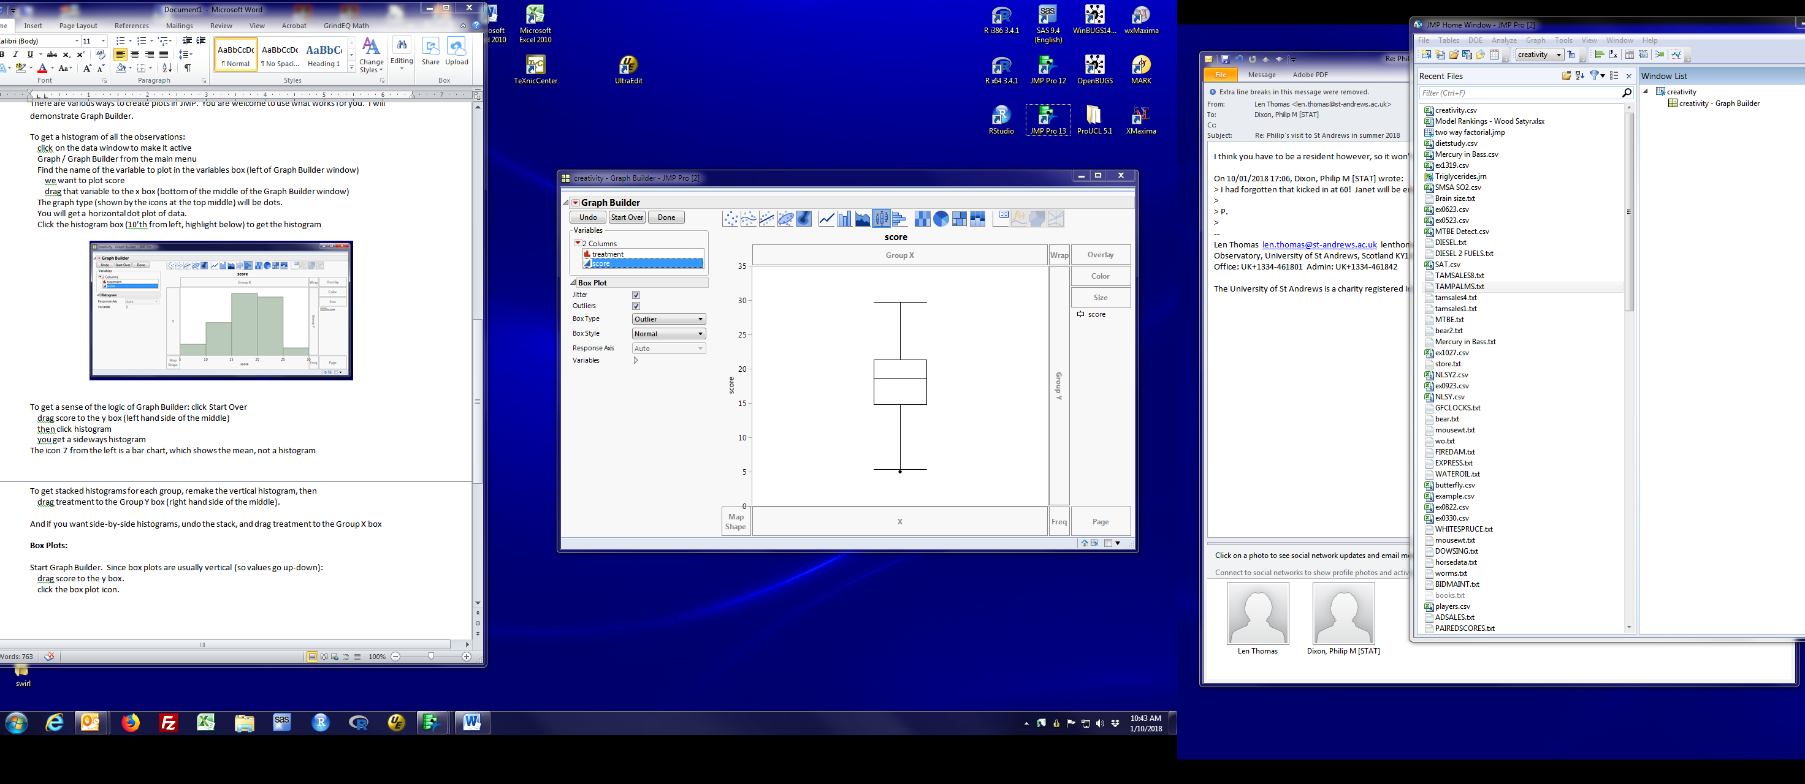

To show side-by-side box plots for the two treatments:

drag treatment to the Group X box

(You could drag treatment to the X box, but the labels are less useful)

(And you be able to predict what happens if you drag treatment to the Group Y box)

**Numeric summaries:**

From the data window, click Analyze / Distribution. That brings up a dialog box that looks like:

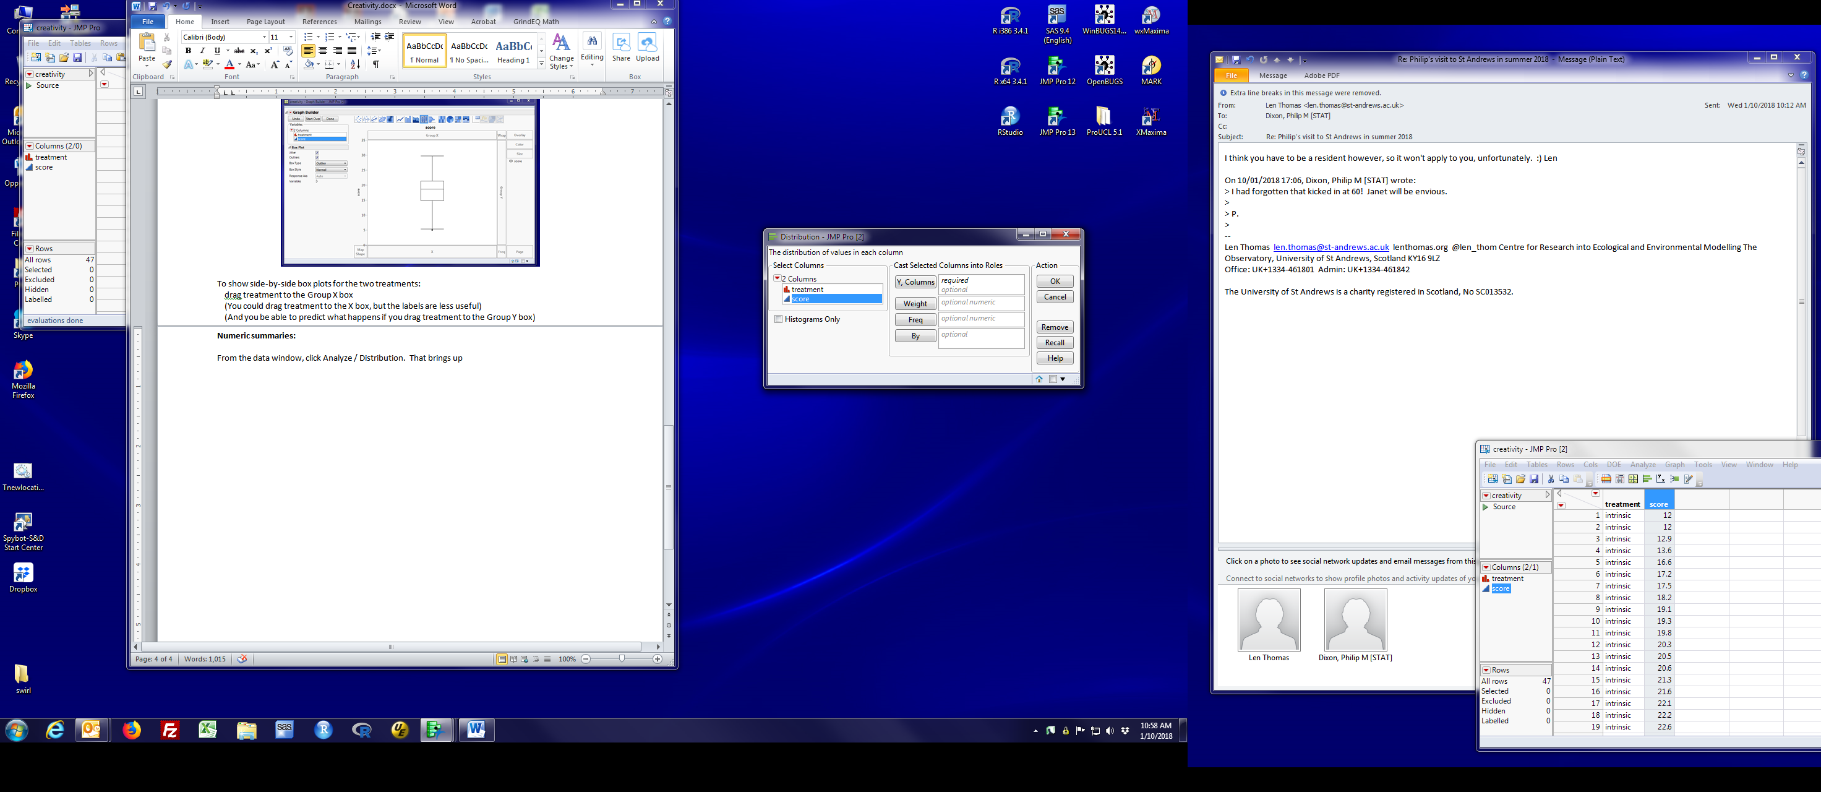

Drag the variable to be analyzed (score in our case) to the Y columns box, then click OK.

If you want two separate sets of analyses, one for each treatment, drag treatment to the By box.

You get three panels for each group of data:

a low-resolution vertical histogram and box plot

a list of quantiles, including the median. (We’ll talk about some of these shortly)

and a box of summary statistics. The names and values are:

Mean: average of the values

Std Dev: sample standard deviation of the values

Std Err Mean: standard error of the mean (discussed in a week or so)

Upper/Lower 95% Mean: 95% confidence interval for the mean (discussed in 2 weeks or so)

N: sample size

You will see red triangles various places in the results. Those triangles hide menus that allow you to request other statistics or suppress parts of the default results. We’ll talk about the ones we need for this course.

**Quitting JMP:**

File / Exit or click the red X to close a window.

You will be asked if you want to save the Data Table.

If yes, JMP saves its internal version of the data as a .jmp file.

This means you don’t have to read the data again to work with it.

You will need to exit from both the data table and the home window

I suggest exiting the data table first.