JMP instructions – analysis of a Latin Square

Uses the data in brome.csv as an example. This has two blocking variables (freeway and stream) and one treatment, trt in a 4x4 Latin Square.

The analysis follows the same principles as the analysis of an RCBD: Include the blocking variables and the treatment in the Fit model box. Then, evaluate the treatment effects as you would in any CRD or RCBD design.

For the data in brome.csv, you do need to flip the blocking variables to nominal. Since they have numeric values, the default import leaves them as continuous (blue ramp) variables. As blocking variables, they need to be nominal (red bar) variables.

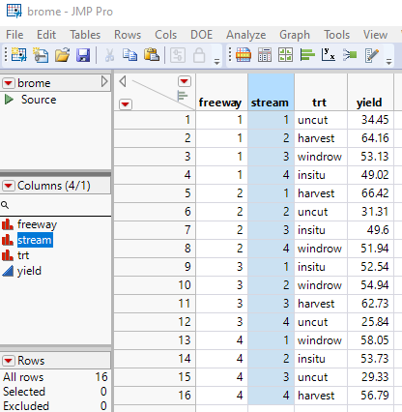

Here are the type III tests and trt least squares means:

