JMP for power and sample size calculations

**Quantiles and tail probabilities**: Two ways – use JMP scripting language (JSL) or use Excel. Much easier to use Excel.

The T quantile function is T.INV(), although TINV() is backwards compatible. Two arguments: probability and df.

=T.INV(0.975, 60) fills the cell with 2.000298

The T probability function is T.DIST(). Three arguments: value, df, and TRUE (for cumulative distribution)

Returns P[X < value].

=T.DIST(2, 60, TRUE) fills the cell with 0.9749

To get upper tail probability, P[X > value], use =1 - T.DIST(2, 60, TRUE)

**Power and sample size directly:**

**\*\*\* WARNING ***:** I don’tget the same results from JMP as I do from R or SAS or hand-calculation. I can’t figure out why and a request to the JMP user community did not get answered.

JMP doesn’t make this easy, although there is good logic behind the approach. If you actually set up an analysis using made up data, then JMP knows exactly what you want to be computing. You just then modify specify the relevant quantities for the design problem.

Two sample T test:

This is either the Analyze / Fit Y by X / Means ANOVA Pooled T dialog or the Analyze / Fit Model dialog. Run the analysis this tells JMP the model you’re using for the data.

If you use Analyze / Fit Y by X / Means ANOVA Pooled T, click the red triangle at the top (by Oneway Analysis …) and choose Power. That will open a Power Details Window.

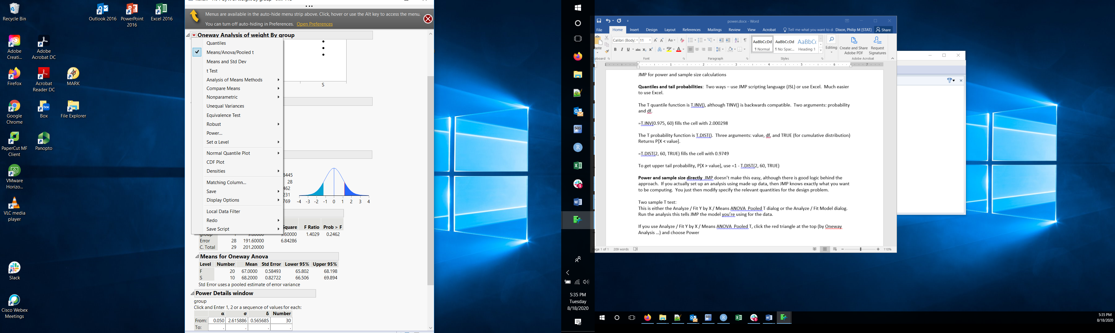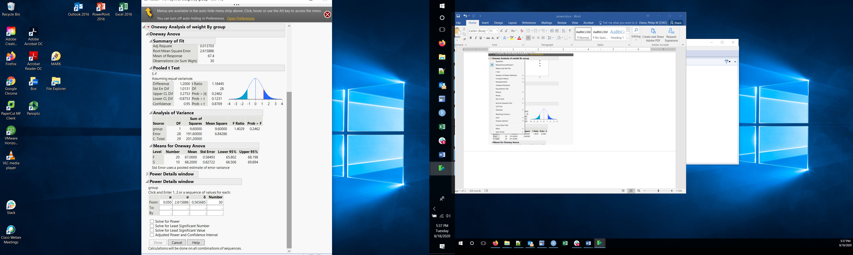

The three columns are populated with values from your analysis. You need to change at least three of them.

Alpha is the significance level, 0.05 is fine

Sigma is the error standard deviation = within group variability

Delta is the difference in means

Number is the number of observations in each group

Enter the desired numbers and click Solve for Power then done you get an extra column with the power.

You can provide a range (From / To / By) for any of the numbers.

If you use Analyze / Fit model, the output is organized differently. One panel has information about the X variable used in the model. Click the red triangle for that variable, and select Power Analysis. You get the same Power Details window