Asparagus example

Philip Dixon

2023-04-12

## Means for each treatment and year, plotted over time

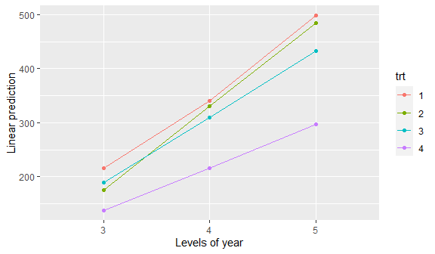

## Means and observations for treatment 4

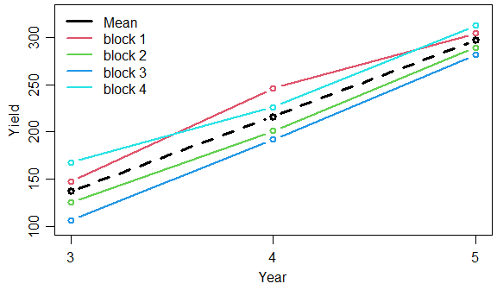

## Residuals for treatment 4

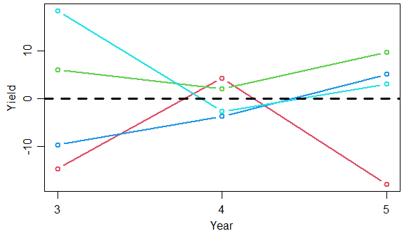

## Correlation of residuals in pairs of years, all 12 treatments

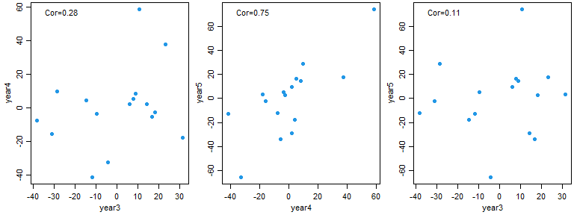

## year3 year4 year5  
## year3 1.00 0.28 0.11  
## year4 0.28 1.00 0.75  
## year5 0.11 0.75 1.00