Lab 1 results

Philip Dixon

2024-08-30

## Results for single rock

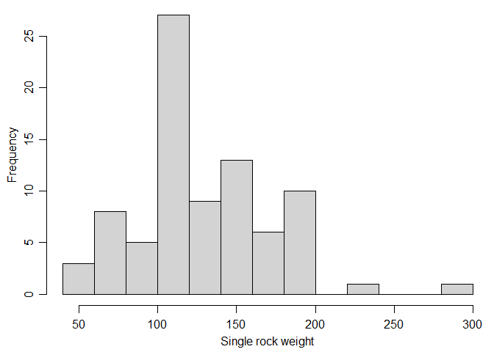

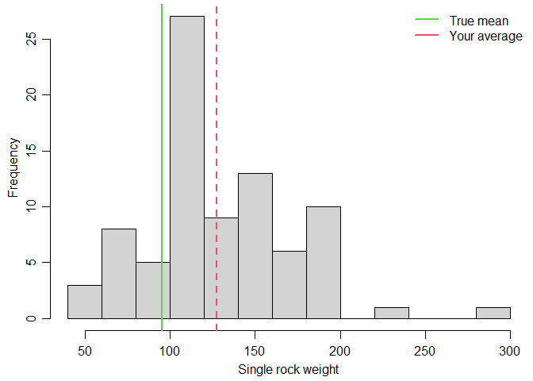

## Choosing 5 rocks to estimate mean

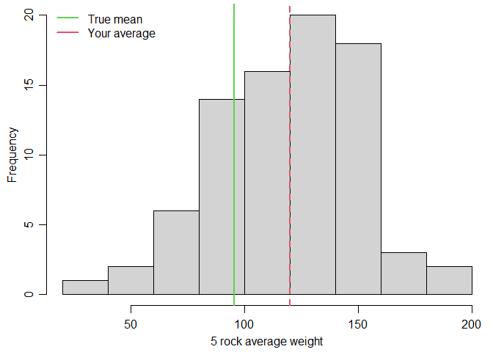

## Choosing 5 rocks to estimate variability (sd)

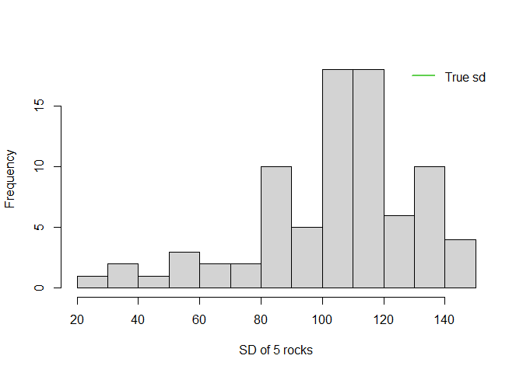

## True simple random samples, 5000 samples, size 1

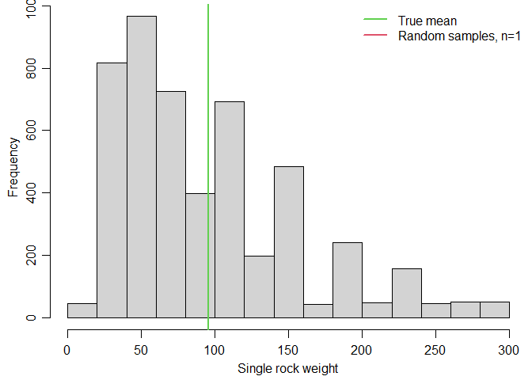

## Simple random samples, 5000 samples, size 5

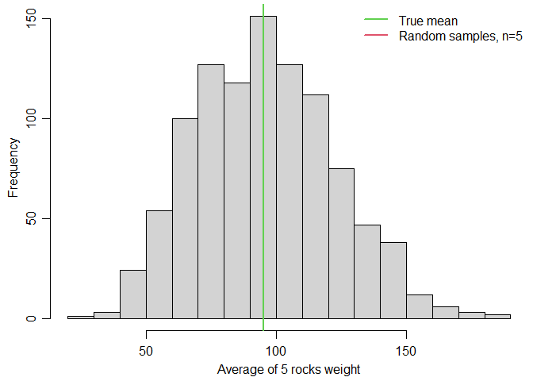

## Using a random sample to estimate variability (sd)

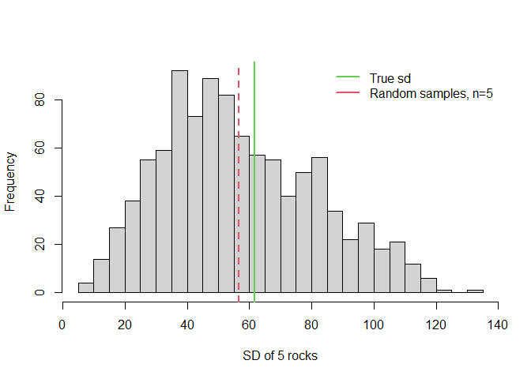

## Using a random sample to estimate variability (variance)

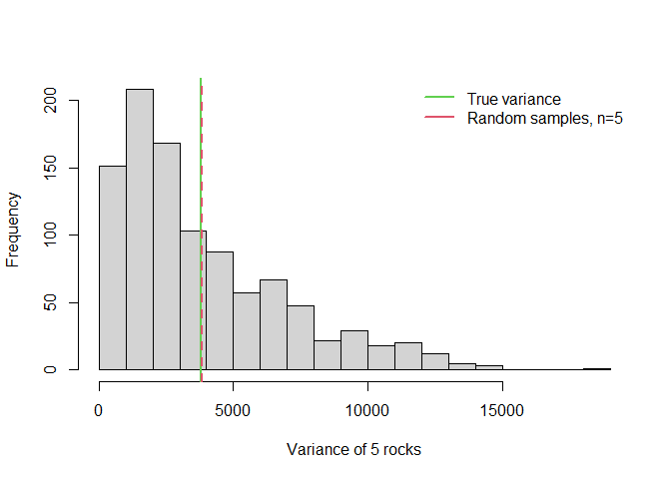

## Randomization test

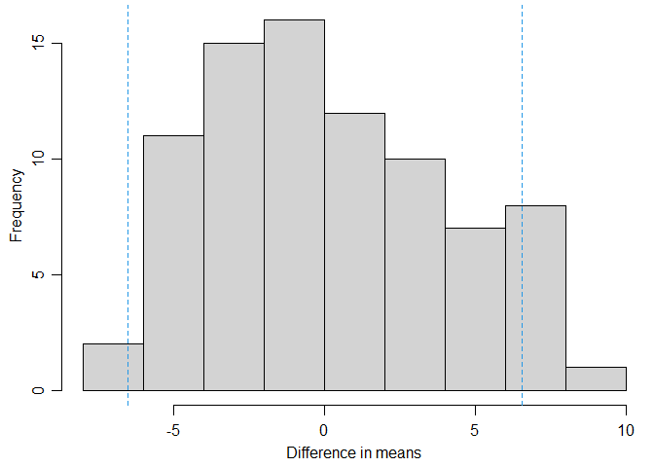

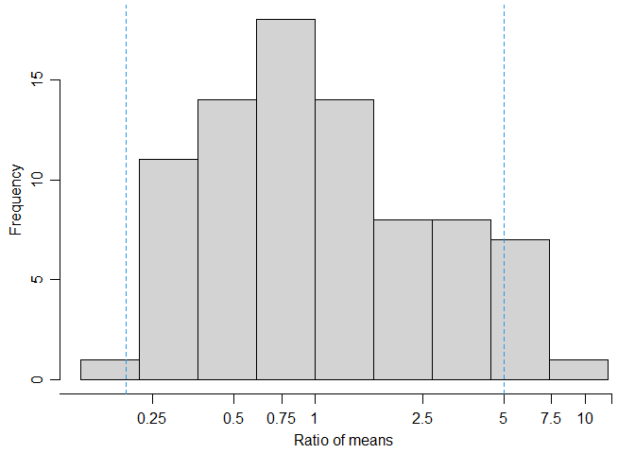

## Choice of software

## # A tibble: 6 × 2  
## software count  
## <chr> <int>  
## 1 JMP 6  
## 2 JMP+(R+SAS) 1  
## 3 R 63  
## 4 R+JMP 1  
## 5 R+SAS 2  
## 6 SAS 10