Lab 1 results

Philip Dixon

2023-08-23

### Weight of one rock

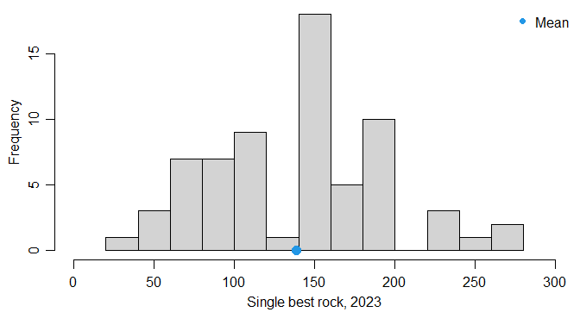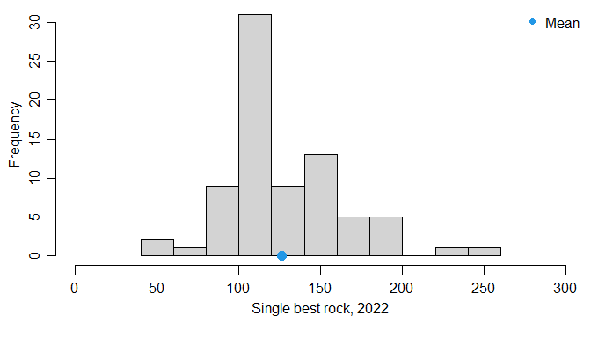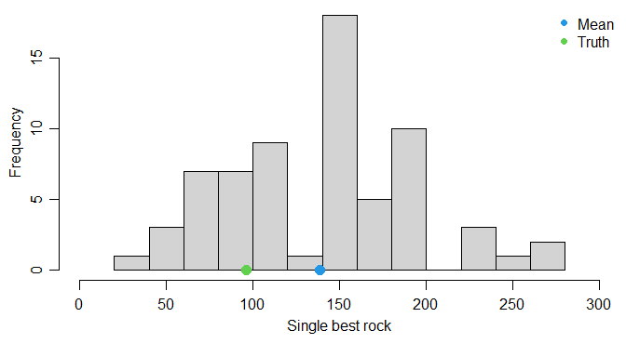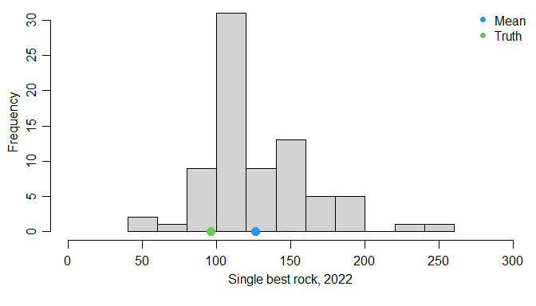

### Weight of 5 rocks

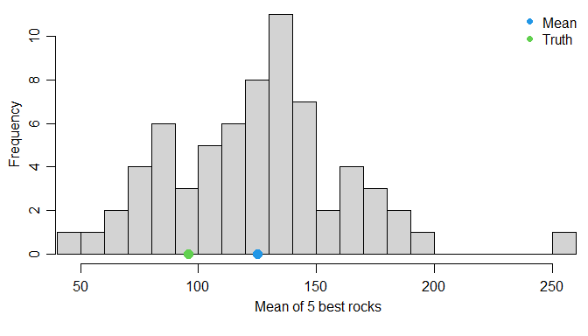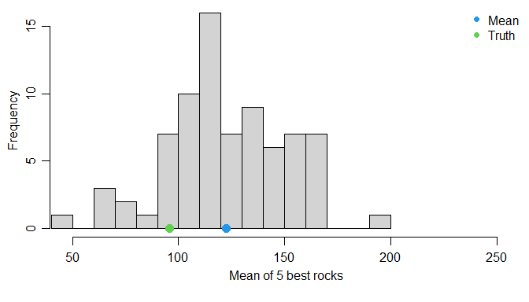

### What if we draw a true simple random sample

Do this 65 times (# of lab1 respondents).

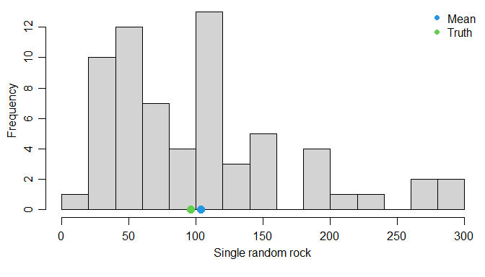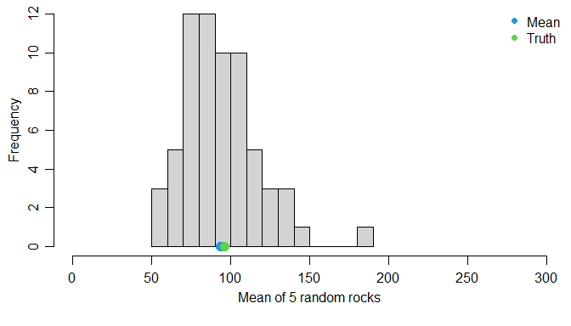

### Randomization tests

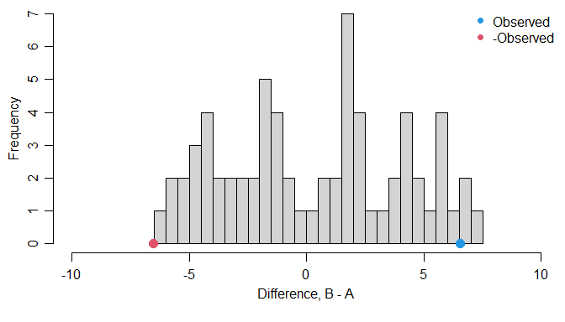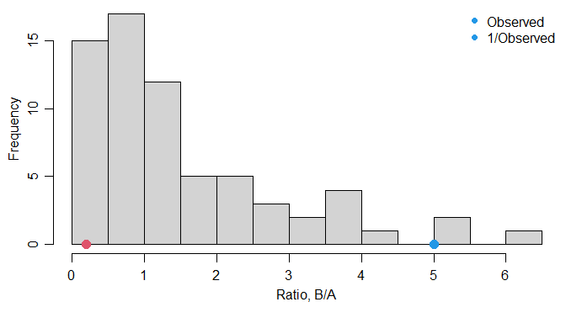

#### P-values from the randomization tests

## One-sided test on difference:

## [1] 0.04477612

## Two-sided test on difference:

## [1] 0.04477612

## One-sided test on ratio:

## [1] 0.04477612

## Two-sided test on ratio:

## [1] 0.04477612